**Spring 2023: CS5710 – Machine Learning**

In-Class Programming Assignment-3

GitHub Link - <https://github.com/raimukul/MachineLearning_Assignments>

Video link- <https://drive.google.com/file/d/12AmiOel5rgY9Ox13Js-YWO1owgW-GTqZ/view?usp=sharing>

**1. Numpy:**

**a. Using NumPy, create a random vector of size 15 with only Integers in the range 1-20.**

1. Reshape the array to 3 by 5
2. Print array shape.
3. Replace the max in each row by 0.

Create a 2-dimensional array of size 4 x 3 (composed of 4-byte integer elements), also print the shape, type and data type

of the array.

b. Write a program to compute the eigenvalues and right eigenvectors of a given square array given below:

[[ 3 -2]

[ 1 0]]

c. Compute the sum of the diagonal element of a given array.

[[0 1 2]

[3 4 5]]

d. Write a NumPy program to create a new shape to an array without changing its data. Reshape 3x2:

[[1 2]

[3 4]

[5 6]]

Reshape 2x3:

[[1 2 3]

[4 5 6]]

import numpy as npy;

*# 1.a*

vector = npy.random.randint(1, 20, 15)

print ("1.a Vector: ", vector)

*# 1.a.1 Reshape the array to 3 by 5*

reshaped = vector.reshape(3, 5)

1.a Vector: [ 1 11 15 3 15 7 1 5 7 9 6 4 6 12 19]

*# 1.a.2 Print array shape.*

print ("1.a.2 Reshaped array shape: ", reshaped.shape)

1.a.2 Reshaped array shape: (3, 5)

*# 1.a.3 Replace the max in each row by 0.*

for i in range(reshaped.shape[0]):

reshaped[i, npy.where(reshaped[i] == reshaped[i].max())] = 0

print ("1.a.3 Replaced max in each row by 0: \n", reshaped)

1.a.3 Replaced max in each row by 0:

[[ 1 11 0 3 0]

[ 7 1 5 7 0]

[ 6 4 6 12 0]]

*# 1.b compute the eigenvalues and right eigenvectors of a given square array*

array = npy.random.randint(1, 20, (4, 3), dtype=npy.int32)

print ("1.b Array: \n", array)

print ("1.b Array shape: ", array.shape)

print ("1.b Array type: ", type(array))

print ("1.b Array data type: ", array.dtype)

1.b Array:

[[13 6 3]

[ 7 19 9]

[17 3 5]

[ 8 11 1]]

1.b Array shape: (4, 3)

1.b Array type: <class 'numpy.ndarray'>

1.b Array data type: int32

*# 1.b*

newArray = npy.array([[3, -2], [1, 0]])

eigenvalues, eigenvectors = npy.linalg.eig(newArray)

print ("1.b Eigenvalues: \n", eigenvalues)

print ("1.b Eigenvectors: \n", eigenvectors)

1.b Eigenvalues:

[2. 1.]

1.b Eigenvectors:

[[0.89442719 0.70710678]

[0.4472136 0.70710678]]

*# 1.c sum of the diagonal element of a given array:*

oneC = npy.array([[0, 1, 2], [3, 4, 5]])

print ("1.c Array: \n", oneC)

print ("1.c Sum of diagonal elements: ", npy.trace(oneC))

1.c Array:

[[0 1 2]

[3 4 5]]

1.c Sum of diagonal elements: 4

*# 1.d new shape to an array without changing its data. Reshape 3x2:*

oneD = npy.arange(1, 7)

print ("1.d Array: ", oneD)

*# reshape to 3x2*

oneD = oneD.reshape(3, 2)

print ("1.d Reshaped array 3x2: \n", oneD)

*# reshape to 2x3*

oneD = oneD.reshape(2, 3)

print ("1.d Reshaped array 2x3: \n", oneD)

1.d Array: [1 2 3 4 5 6]

1.d Reshaped array 3x2:

[[1 2]

[3 4]

[5 6]]

1.d Reshaped array 2x3:

[[1 2 3]

[4 5 6]]

**2. Matplotlib**

1. Write a Python programming to create a below chart of the popularity of programming Languages.
2. Sample data:

Programming languages: Java, Python, PHP, JavaScript, C#, C++

Popularity: 22.2, 17.6, 8.8, 8, 7.7, 6.7

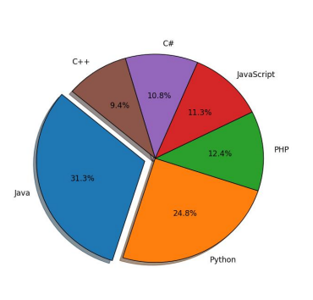

*#2*

import matplotlib.pyplot as plt

programmingLanguages = ['Java', 'Python', 'PHP', 'JavaScript', 'C#', 'C++']

popularity = [22.2, 17.6, 8.8, 8, 7.7, 6.7]

dictionary = dict(zip(programmingLanguages, popularity))

dictionary = dict(sorted(dictionary.items(), key=lambda item: item[1], reverse=True))

explode = (0.1, 0, 0, 0, 0, 0)

plt.pie(dictionary.values(), labels=dictionary.keys(), explode=explode, autopct='%1.1f%%', shadow=True, startangle=135)

plt.axis('equal')

plt.show()

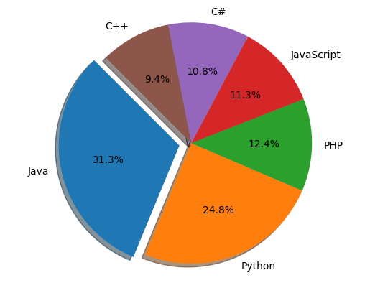

Screenshots:

